Veronica Kordmany
ENGL 399W
3/10/2022

‘The Othering of the Jew’:
Art Spiegelman’s Maus: A Survivor's Tale:

When thinking about the historical discourse of Jewish literature, a topic that is almost always spotlighted is the Holocaust. ‘Historicism’ is defined as the attribution of significance to a historical space or time, such as a historical period, culture, or geographic place. A genocide of epic, irreparable proportions, the Holocaust represents a gaping hole in Jewish identity, which was formed by its profound impact on how Jews operate in the world in the contemporary era. Author and cartoonist Art Spiegelman calls upon these historical events and ideas of the Holocaust through the testimony given by his father, who was a survivor. Spiegelman’s decision to write his father’s account of the Holocaust in the graphic novel Maus: A Survivor's Tale, for which he ended up receiving the Pulitzer Prize, eventually being hailed as one of the pioneers of utilizing comics as literary scholarship. In this paper I will argue that the historical discourse of the Holocaust, which marks the marginalization of the Jewish people, can be traced all the way into the contemporary era through the work of Art Spiegelman, whilst using an anthropomorphic lens. In doing so, I aim to provide some insight into what is significant about the anthrpomorphism of the Holocaust as it pertains to the Jewish people from both the past and the present. More specifically, I am interested in exploring how memory, trauma, and postmemory all come into play within the context of the graphic novel.
History of Marginalized Jews:

Art Spiegelman is the son of Polish Jews Władysław, also known by his Hebrew name Zeev, and Anna Spiegelman, both of whom were Holocaust survivors. Born in Stockholm, Sweden, Art and his family immigrated to Queens, New York, in 1957, when he was just a child. In 1972, Spiegelman was offered the chance to write a three-page strip for a comic book, which gave him the opportunity to write his family’s story. The finished product was turned into his graphic novel, Maus: A Survivor's Tale. Maus adds to the general collection of Holocaust literature with an interesting adaptation; by utilizing anthropomorphism as a symbolic device, Art Spiegelman uses his artistic skills to shed a new light on the way contemporary readers process and understand the depths of tragedy and grief of the Holocaust.
Spiegelman’s anthropomorphic representation of Germans as cats, Jews as mice, and Poles as pigs is one of the reasons for the novel’s success, as it properly conveys the stereotypes associated with individual ethnicities that existed in the Holocaust. When approaching the Holocaust from a literary lens, one must carefully consider the temporal memory that carries from the past into the contemporary era. Some consider the storytelling of this historical landmark to be cathartic, meant to appease the ill-memory of it all by providing some sense of closure. Others believe that it isn’t possible for that closure to ever come, a limitation that creates a shroud of everlasting uncertainty.
In “The Holocaust as Vicarious Past: Art Spiegelman's Maus and the Afterimages of History”, scholar James Young focuses on the perspective of historian Saul Friedlander, who paves the way for approaching this topic. Young writes, “Though as a historian Friedlander questions the adequacy of ironic and experimental responses to the Holocaust, in-sofar as he fears that their transgressiveness undercuts any and all meaning, he also suggests that a postmodern aesthetics might “accentuate the dilemmas” of historytelling” (Young 666). The ‘aesthetics’ that Young and Friedlander are making reference to is “an aesthetics that remarks its own limitations, its inability to provide eternal answers and stable meaning” (666). Young points out that what Friedlander worries, as a historian, is that the representation of the Holocaust, and the collective memory passed on through generations, may forever be hindered upon the uncertainty of it all. He outlines two types of memory - ‘common memory’, which is the ability to establish or restore closure, even redemption, and ‘deep memory’, which is the essentially interpretable; the inarticulable component which is going to forever remain, “unresolved trauma just beyond the reach of meaning” (667). Friedlander presents these two concepts with the notion that one does not resolve the other, but instead that they are intertwined. In every piece of ‘common’ memory there will always be a small piece of ‘deep’ memory embedded in it - a small yet viable reminder that there’s a lingering piece of trauma that’s never really gone.
There is one scene from the novel that Young takes particular interest in. For context, it is revealed during a flashback scene in Chapter Four that prior to having Art, the Spiegelmans had another son, Richieu. During the War, in a heart-wrenching decision made to ensure his safety, Richieu was given to Vladek’s good Polish friend Ilzecki: “I have a good friend, a Pole, who’s willing to hide my son until the situation gets better” (Spiegelman 81). But eventually, that decision ended up being the wrong one. It wasn’t until it was too late that the Spiegelmans learned what their son’s fate was. Anja’s sister Tosha, who was in charge to keep her nephew and two other children in her care safe. But when news broke out that the Jews of Zawiercie were being sent to Auschwitz, ended up deciding that instead of going to the gas chambers, she and the children would drift off into an eternal sleep instead. “Always Tosha carried around her neck some poison… she killed not only herself, but also the 3 children” (109). Young takes us to this scene to exemplify Friedlander’s categorizations of memory. In this methodology, the ‘common memory’ is the comprehension of Tosha’s actions, looking back at that time. Vladek is able to talk about his son’s demise, and is able to find some solace in what Tosha did, because he knew first-handedly what the alternative outcome could have been. He could have thought that Tosha didn’t necessarily want to commit mass suicide, but inherently her actions guaranteed a merciful death; one that let them all die peacefully, rather than be condemned to a fate worse than death. If Tosha hadn’t done what she had done, the presumption was that the Nazis would have found her, Richieu, and the other children. The ‘deep memory’ is Vladek’s storage and processing of this series of events: Giving up his son, not hearing about him for a year, only to find out that his own family took away his son’s life. The ‘deep memory’ comes from the common memory: Being able to grapple with what had happened, but not being able to put it to rest. Although he has found closure over time, as we see through his ability to recall what had happened, Friedlander’s definition of ‘deep memory’ demonstrates that closure doesn’t encapsulate all of the trauma. In order for us to apply Friedlander’s understanding to Spiegelman’s comic novel, however, we must look to the anthropomorphic visuals to understand how Spiegelman interprets these narratives and truths.
Looking at the top right panel on page 109 [Figure 1] we see the scene unfold: Tosha receiving the news from a passerby, making the decision on her own, and finally, putting her plan into action. The words ‘Bang Bang’ are etched in the corner of the panel to emphasize the chaotic background noise going on, as two mice/Jews are running past Tosha’s open window, to which she exclaims, “More gunshots! What’s going on?” (109). While it’s hard to physically distinguish much about the three figures, some anthropomorphic details make up for the lack of context. Tosha’s friend runs by wearing a head covering, which is a Jewish custom for married women to wear as a form of modesty. However, Tosha isn’t wearing one; in fact, neither of them don’t even have hair. Although they are technically female mice, the head covering serves as a reminder that there were many different religious types of Jewish women co-existing at the time. Spiegelman’s decision to differentiate these two women demonstrates that their representation as mice doesn’t obscure their Jewish identities as human women. Both Tosha and this unnamed character are both anatomically the same, in mice form, but their Jewish observances are what differentiates them from each other. In essence, Vladek’s recollection is a temporal testament to the existence of memory. As Young writes, Friedlander is proposing “...not so much a specific form but a way of thinking about historical narrative that makes room for a historiography that integrates deep and common memory” (667). Thinking through this historicism reminds us that the testimony being illustrated is a remembrance of a historical event; it is a recollection of human memory that is fragmentally decomposing as time passes by. One of the reasons that Friedlander proposes for why Holocaust testimonies are important, is because of the imperativity of integrating “both the contingent truths of the historian's narrative and the fact of the victims' memory, both deep and common” (668).
Understanding the Traumatized Jew

In a bombshell moment, Art reveals more about his family’s personal turmoil in one scene than he does for most of the novel. On page 100 [Figure 2] Art's stepmother, Mala, shows him a comic that he had drawn years ago, after Vladek accidentally finds it. Called Prisoner on the Hell Planet: A Case History, Art takes a break from Maus to recollect the painful story of such a vividly-dark time in his life:
“My father found her when he got home from work… her wrists slashed and an empty bottle of pills nearby… I was living with my parents, as I agreed to do on my release from the state mental hospital 3 months before… I suppose that if I’d gotten home when expected, I would have found her body” (100).
Through etchings and speech bubbles, we gain intimate insight into the trauma that had been passed down from Spiegelman generation to generation.
The first thing that is noticeable is the fact that Art doesn’t use anthropomorphism: all of the characters are very much human. On the cover page is a real photograph of a grinning son with his watchful mother, presumably Anja and Art, taken at a utopian time during his childhood. But throughout each panel is a starkly different tone: Art, wearing his pinstripe hospital clothes, dons a melancholy, ghoulish facial expression heightened by chiaroscuro. As if a prisoner to his own upbringing, each panel watches Art going through the motions of a horrific nightmare. His skeleton-like figure is shrouded in darkness when he exits the subway. His expression is masked by the sea of faceless people heralded around his house. But most notably, we can’t see anything when the news is broken. Doctor Orens is reduced to a pair of glasses, shouting, “Your mother killed herself - she’s dead!” (101) with a mad scientist demeanor, while Art’s back is turned to us. The reaction is sort of psychedelic [Figure 3]; thin strips show a sequential portrait of the tears pouring down his face, while the Doctor’s face looms in front of him, shouting “She’s dead! A suicide!” (101). As Art and Vladek cry in each other’s arms, or more specifically while Vladek cries into Art’s arms, his hospital uniform bears an eerie resemblance to a prisoner’s uniform, as if to say he was a slave to his family’s misfortune.
As he moves on to the funeral scene, the facade of numbness begins to crack as the reality of Art’s situation begins to settle in, making room for hostility. In a haze of imagination mixed into memory, the interior of Art’s mind is a jumbled mess of guilt and anguish, as he creates scenarios where he is to blame for his mother’s suicide. On page 103 [Figure 4], he imagines that the friends of his father are silently attacking him for his part in Anja’s death, while the reality is that they’re just offering him condolences. Regardless of what really transpired, it was enough to send Art into a negative spiral: “Menopausal depression”, “Hitler did it!”, “Mommy!”, and “Bitch” all spiral around his fetal-positioned body, thoughts looming over his head (103). But what speaks louder than these Freudian slips is the artwork. Combined with Art’s prisoner uniform, featured in the panel is: a swastika on the wall, a heap of corpses, an outstretched arm with a serial number tattooed, another arm about to be punctured with a razor, and the faces of Anja and Vladek Spiegelman. All of these images race through Art Spiegelman’s mind because they are the nightmares he is burdened with; the constant reminders of his family’s agony that he is forced to carry with him forever, until he can eventually dump it onto the next generation of Spiegelman’s.
The break that Spiegelman takes from his father’s account of the Holocaust, to instead tell this story, illustrates the idea that Holocaust trauma and grief is manifested into generational trauma; the temporality of this vicious cycle. The rotation between violence and trauma extends beyond time and space. Spiegelman takes a hiatus from Maus to encapsulate the essence of what it means to not just survive trauma, but to live in the aftermath of it. In Chapter 2 of their book, Third-Generation Holocaust Representation: Trauma, History, and Memory, authors Victoria Aarons and Alan L. Berger examines the transmission of ‘survivor writing’ from first-hand accounts down to second-and-third generation recipients. As written, “Those generations of witnesses who follow the survivors in their attempts to extend the traumatic history of the Shoah into the present are custodians of the past” (Aarons, Berger 43). What Aarons and Berger are demonstrating is the common belief that Holocaust literature is driven by an innate fear that the common memory of the survivors would be lost on its way into the present era. Maus is an excellent example of this, as it is one of the reasons survivors agree to have their testimonies written for literary purposes. When applying Chapter 2 to Prisoner on the Hell Planet: A Case History, an emerging interpretation of the passage(s) is that “...the trauma extends not in the reenactment and reconfiguring of the event, but in the absence of conscious or unconscious perception of the reality of the experience” (45). In the moment when Art was experiencing the loss of his mother in real time, we see that he is not fully ‘there’ mentally; He says at one point, “My father fought for self-control and prayed. I was pretty spaced out in those days” (103). Aarons and Berger are explaining that a potential reason for this is because the trauma hadn’t manifested yet, that trauma is a product of time and space from the actual historical event.

The Othering of the Jew:

The anthropomorphism of the characters in Maus is a commentary on the marginalization of the Jewish people, a concept that is predicated on anti-Semitism that’s been exacerbated by the Holocaust, the final result of which is exemplified through Maus. Many objected to Spiegelman’s anthropomorphic ideas, citing that the ethnic depiction of mice, cats, pigs, and dogs, as people tends to be too close to home for readers; however, this is counteracted by the artistic decision to keep humanlike qualities embedded in these characters. The four-legged animals are two-legged, meaning that they walk around like humans do. They speak human language, wear human clothes, and operate the way that humans normally do. Essentially, Spiegelman only characterizes these ‘animals’ in caricature. The subculture of these ethnicities represent the diaspora of people that the Holocaust influenced; each of them represent a different persona that existed during the Wat. But what we see on many occasions is that this is a story about community trauma, not intimate trauma. While these different communities came together against one oppressor, they also developed unique manifestations of trauma that pitted them against one another, creating a Darwinian social atmosphere where everyone was focused on keeping themselves alive first and foremost.
For instance, the representation of Poles as the ‘pigs’ throughout the novel is interpretable in various ways. Spiegelman portrays the pigs as being notoriously symbolic of greediness and snobbery, yet at other times, these pigs are also representative of helpfulness and generosity. As to which aspect of the pigs to place trust in, the greedy side or the generous side, Spiegelman tells us that the answer is both of them. The intersectionality of the Spiegelmans being both Polish and Jewish poses the big question of ‘ethnic loyalty’, a term I use to refer to the spaces in between ethnic groups and whether or not it is possible for them to overlap. I will prove that ethnic loyalty is possible to exist, but not always.
On page 64, Vladek comes to the train station without the proper paperwork, wondering how he would ever be able to return to his hometown, Sosnowiec. Seeing that the ‘Train Man’ is Polish, Vladek literally masks as a Pole by wearing a pig mask. But more importantly, he passes as a Pole without revealing that he is a Jew as well. Confiding in the Train Man, he says, “You’re a Pole like me so I can trust you… The stinking Nazis had me in a war prison… I just escaped” (64). In this scene, Vladek is drawing upon the connection between Jewish and non-Jewish Polish people: their mutually-assured hatred of the Germans (64). The fact that Vladek successfully establishes a kindred relationship with the Train Man, even if it’s for the purpose of exploiting him in order to safely return home, nudges at the ‘generous’ side of Polish virtue. But what is equally essential in understanding is that this bringing together of two Poles, two ethnic beings, is only made possible by erasing his Jewish ethnic background from sight. The stereotype of greediness surfaces when Vladek and Anja bounce from acquaintance to acquaintance, looking for a single kind soul to spare them from living out in the cold. Their first stop is at Janina’s, Richieu’s governess’, house. Upon realizing that they’re still alive, all she says is, “You’ll bring trouble! Go away! Quickly!” (136). She shuts the door in their faces, as if the years of working with them had never happened at all. Next, Anja brings them to her father’s old house, where the janitor still resides. At first, it seems as though they finally catch a break, as Mr. Lukowski brings them into the hearth of the home. But then suddenly, their hopes come crashing down as a Polish woman yells, “A Jewess! There’s a Jewess in the courtyard!” (137). And once again, just as fast as their spirits rise the slightest bit, it plummets right back to the bottom once more. Although the Spiegelmans were lucky enough to escape those times, the memory of being turned on by their own neighbors, people who used to have such big parts of their lives, lingered behind. The reinforcement of this traumatizing, abrupt rejection that persists throughout the story nods to the ‘othering of the Jew’ factor that serves as the basis of the Jewish undertone of Maus. Although many factors group Holocaust survivors together, the commonality of surviving the same War conjoining them forever, it’s like each anthropomorphic entity operate in their own worlds.

The Continued Legacy of the Holocaust:

While the success of Maus is mostly attributed to the rarity of the graphic novel genre being employed to convey such deep, dark subject matter, one scholar argues that Maus isn’t just a graphic novel. Scholar Rosemary V. Hathaway’s scholarly article, “Reading Art Spiegelman’s Maus as Postmodern Ethnography”, testifies that to consider Maus to just be a graphic novel would be a disservice to the genre (Hathaway 249). She argues that there are many ways to consider the genre of the novel, ones that she doesn’t necessarily agree with. One of those is the autobiography, since Art is telling the story as a main character who consistently both enters and disrupts the story. It can also be read as an oral history, or oral biography, of Vladek Spiegelman’s past encounters as a Holocaust victim. But before I delve into her interpretation of the novel’s genre, I think it’s essential to highlight the other contributing voices to the argument. Many scholars and critics believe that this novel is either a biography or historiography, some even going so far as to classify it as both. Critic James E. Young provides the label of ‘received history’, arguing that ““Spiegelman’s Maus makes a case for an essentially reciprocal relationship between the truth of what happened and the truth of how it is remembered”” (251). This is the closest argument to Hathaway’s, who proposes her notion that Maus is a “postmodern ethnography” (251). Ethnography, in this context, refers to “...texts [that] are concerned with depicting the complex relationships among personal histories and larger “official” histories” (249). I aim to engrain Hathaway’s argument, that Maus can be read as a postmodern ethnography, in order to explore the navigation of these traumas and memories that began with Vladek Spiegelman, now being passed down as Art Spiegelman becomes the receiver of his family’s history. As Hathaway explains it, “Many critics have also commented on the ways in which the Maus books underscore the phenomenon of postmemory: Art’s own stories often focus on the ways in which his family’s Holocaust trauma has become his trauma, and the ways in which he has inherited his parents’ survivor guilt” (250). In order to establish her argument, Hathaway brings us to the very beginning of it all.
On page 1, the first thing we see is Art saying, “I went out to see my Father in Rego Park. I hadn’t seen him in a long time—we weren’t that close” (11). Immediately after, we learn about his mother’s suicide and the community’s state of survivorhood. The desire to write about his family history is strong enough for Art to reunite with his father after years of estrangement, as he makes clear right upon his arrival: “I still want to write that book about you… about your life in Poland, and the War”, but his outreach is shut down with an adamant “It would take many books, my life, and no one wants anyways to hear such stories” (11). But as we know, Art successfully draws the story out into the open, and begins the work of postmemory throughout the course of the novel. Although the tale-telling is a little fragmented, as Vladek’s memory is beginning to fade at certain moments, Art is able to get a sufficient amount of material to work with for his novel. Hathaway calls attention to this scene in order to connect it to the end of the novel, right at the beginning of Chapter 6. When he arrives, Art comes into the house to see Mala crying in the kitchen. Asking her what happened prompts her to open an emotional floodgate, as she begins to tell her own struggles with being a Holocaust survivor, and also living with one.
On page 130 [Figure 5], she cries about Vladek’s maltreatment, giving explanations like “He only gives me $50.00 a month. When I need a pair of stockings I have to use my own savings!” and “When I try to argue with him he moans like he’s going to have another heart attack. I can’t be sure if he’s faking, so I have to stop!” (130). Interestingly, Art finally has something to converse with her about, as he relates with his own personal experience: “Well… he hasn’t changed. Whenever I needed school supplies or new clothes Mom would have to plead and argue for weeks before he’d cough up any dough!” (130). What emerges from this dialogue is a prime example of Hathaway’s topic of postmemory. While the memory operates in the past, the preservation of that trauma and experience, the postmemory is the debris from that emotional battleground. The postmemory is the ways in which the effects of that trauma and experience express themselves in the present era. In this case, the way in which the postmemory of Vladek Spiegelman is delivered is through these frustrating, incomprehensible intricacies that drive his family crazy. It is common with Holocaust survivors to find little ways of adjusting to their irreparably-changed lives; for Vladek, keeping a tight hold on things that he lost during the Holocaust, like money and clothes, helps him maintain a sense of normalcy. If he has these things at all times, then everything will be okay. Mala’s meltdown gifts Art with another component of postmemory - her own testimony. “Fah! I went through the camps”, she shares. “All our friends went through the camps. Nobody is like him!” (131). Although she doesn’t go into the entire history of her time during the Holocaust, the things that she complains about gives Art the ability to understand what is unique about his father, specifically as a survivor, versus what is shared amongst other survivors.
Contributing to this concept of post-memory, and the inheritance of Holocaust memory from the second-generation ‘survivors’, is scholar Philip Roth in his literary review, “Spiegelman Studies, 1 of 2: Maus”. In the chapter “The Second-generation Survivor”, Smith calls upon other scholarly research to shed light on the role that Art plays in postmemory:
“Hirsch submits that ‘[p]ostmemory characterizes the experience of those who grew up dominated by the narratives that preceded their birth, whose own belated stories are evacuated by the stories of the previous generation shaped by traumatic events that can neither be understood nor recreated” (Smith 502).
We see a first-hand account of this in the Spiegelman’s kitchen, as Art reaches out to Mala with his own fears and personal qualms with how to properly handle this postmemory. “It’s something that worries me about the book I’m doing about him… In some ways he’s just like the racist caricature of the miserly old Jew” (131). In coming face-to-face with this social stigma surrounding the portrayal of Holocaust survivors in history, ‘the racist caricature of the miserly old Jew’, Spiegelman is drawing attention to his personal identity as the storyteller of the second-generation survivor. As Smith points out, Art Spiegelman’s entire identity is predicated upon this facet of being a survivor’s son. It’s the basis for his work; the project that gives his life meaning. So what he fears, as Mala chooses to laugh at, is dropping the ball with his father’s testimony. To be given the precarious chance to tell such a unique and prominent story comes with a great amount of responsibility. When Art wrote this story, he had to be delicate in how he went about it. If he reverted his father’s legacy to nothing more but a racist notion that Vladek Spiegelman the Holocaust survivor is nothing more than a money-hogging, frugal, difficult to live with man, then he would be fail.
What Hathaway and Smith both demonstrate in their respective works is that the work of telling a Holocaust tale is never finished. Even after he finished the novel, Art Spiegelman’s responsibility to his father wouldn’t end. As Hathaway perfectly encapsulates, Vladek’s decision to end his recounting of his time during the War. But for the reader, “...this recursive story cannot ever truly end. Just as a well-constructed postmodern ethnography often leaves its readers more intrigued than sated about the subject in question, Maus, too, leaves readers wondering if they truly got the whole story—and moreover, what kind of story it was” (265).

Conclusion:

Anthropomorphism is a creative mechanism that authors use to digress from a too-real reality, departing from the normal conventions of literary characterization. It helps the reader understand the core of a story from an unbiased perspective. In this essay I worked with Art Spiegelman’s graphic novel Maus: A Survivor's Tale as an anthropomorphic historical representation of how trauma, memory, and postmemory operate over the course of history, begining in the past historical era of the Holocaust, leading up to the present, contemporary era. Encapsulating postmodern theories about race and trauma, Spiegelman accomplishes establishing the ‘Otherness of the Jew’ as a strong-willed, impenetrable body that withstands all of its opponents. First the Nazis came, and the Jews won. The Poles turned on them, and the Jews came through alive. Then the Americans came, and the Jews assimilated into a new world while maintaining their cultural identity. Spiegelman uses his family’s story not to add to the collective of survivor testimonies that exist in the world, but to rebuke the notion that survivors’ are merely stories to be mirrors of those who read them.
Using anthropomorphism isn’t just about how to understand who was a part of the Holocaust, it’s about how they were a part of the Holocaust. Presenting the Jews as mice is to enhance the feeling of victimization, of slipping through the fingers of oppression at every possible encounter. Visualizing Poles as pigs isn’t simply to present them as greedy nor, complicatedly, as sympathetic either. And picturing the Germans as cats doesn’t just reinforce stereotypes about their sly and volatile demeanors. But what these visions accomplish is starting a conversation about visual and figurative representation. Spiegelman’s artistic decisions have blown open the discussions of how to look at the representation of the Holocaust: instead of shying away from racist caricatures, for fear of being called out for perpetuating wrongful stereotypes, he expertly utilizes them to grab people’s attention. His aim, which I argue in this paper that he does successfully, is to recalibrate what those stereotypes say about these ethnic groups.
The concepts of memory, trauma, and postmemory represent a complicated web of human emotion that only a select few can handle the navigation of. Throughout this paper I provide textual evidence from the story to establish the framework for these subjects as they relate to the different facets of the Holocaust. These subjects cover a wide span of themes, such as the suicide of Anja Spiegelman, a Holocaust survivor that buckled under the haunting experiences that followed her out of Nazi Germany. The death of Richieu Spiegelman, whose memory still plagues both Vladek and Art Spiegelman today. To take it a step further, Art had never even met his older brother, yet the mere memory of him is something that adds to the personal burden he carries around with him. The living, breathing story that is Vladek Spiegelman, on which this entire graphic novel is predicated. Vladek is the focal point of Maus: He is who everyone and everything revolves around. Without him, there would be no Spiegelmans to pass down this unfortunate family inheritance, both intergenerationally and with the rest of the world.
The goal of stretching out all of these concepts, of telling all of these stories, is simply to educate. Art Spiegelman could have kept his family’s story to himself, just as Vladek chose to do with Anja’s personal diaries that she kept during the War. But when he thought about his place in time and history, looking back at how the world handled the topic of the Holocaust both during and immediately after its aftermath, he knew he had to step up. As he writes in the very beginning of the novel, ‘The Jews are undoubtedly a race, but they are not human’. I think that the reason why he chose to include that quote, from Adolf Hitler, is to redefine what it means to be both Jewish and human. There are many different races and ethnicities associated with the shrapnel of the Holocaust, but there aren’t too many people left to defend their legacies.

Works Cited:

Aarons, Victoria, and Alan L. Berger. “The Intergenerational Transmission of Memory and
Trauma: From Survivor Writing to Post-Holocaust Representation.” Third-Generation Holocaust Representation: Trauma, History, and Memory, Northwestern University Press, 2017, pp. 41–66, http://www.jstor.org/stable/j.ctt22727kb.5.
Friedländer, Saul. “History, Memory, and the Historian: Dilemmas and Responsibilities.” New
German Critique, no. 80, [New German Critique, Duke University Press], 2000, pp. 3–15, https://doi.org/10.2307/488629.
Hathaway, Rosemary V. “Reading Art Spiegelman’s <em>Maus</Em> as Postmodern
Ethnography.” Journal of Folklore Research, vol. 48, no. 3, Indiana University Press, 2011, pp. 249–67, https://doi.org/10.2979/jfolkrese.48.3.249.
Philip Smith, “Spiegelman Studies, 1 of 2: Maus,” Literature Compass 12/10 (2015):
499-508.
Young, James E. “The Holocaust as Vicarious Past: Art Spiegelman’s ‘Maus’ and the Afterimages
of History.” Critical Inquiry, vol. 24, no. 3, The University of Chicago Press, 1998, pp. 666–99, http://www.jstor.org/stable/1344086.

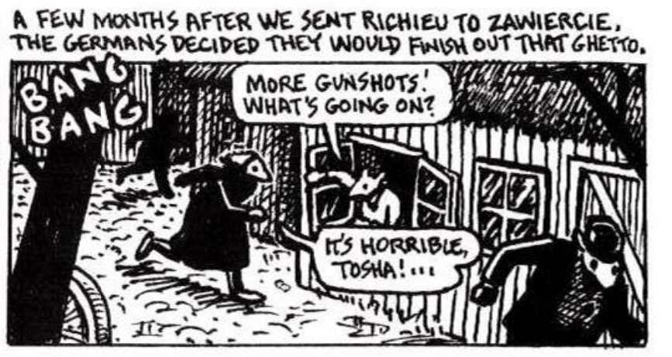Figure 1
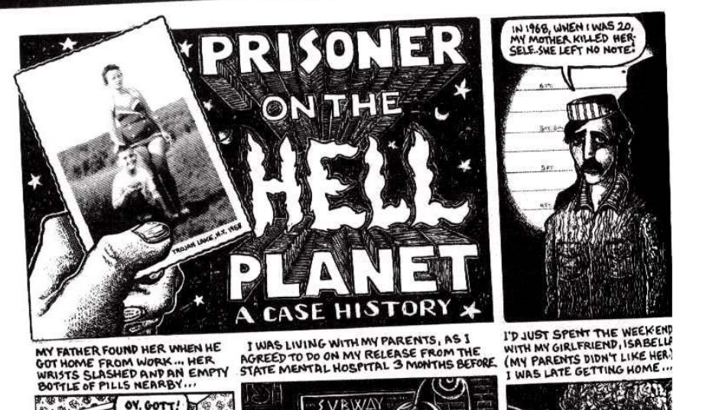Figure 2
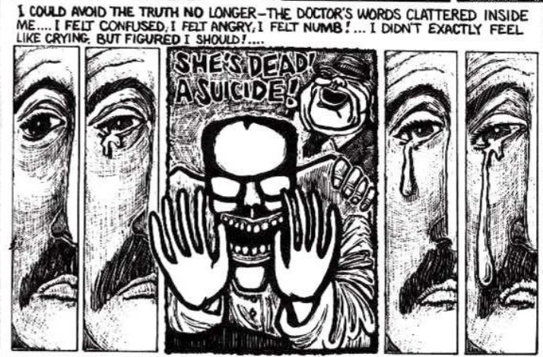Figure 3
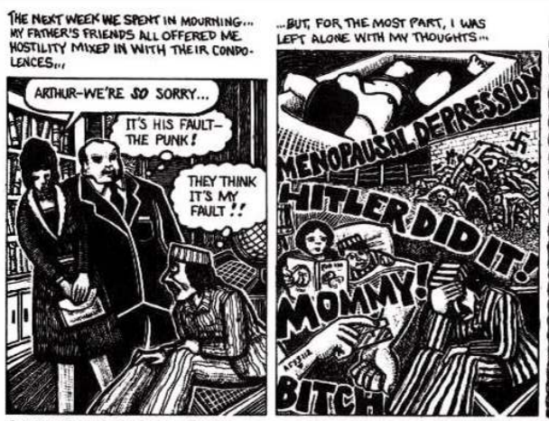Figure 4
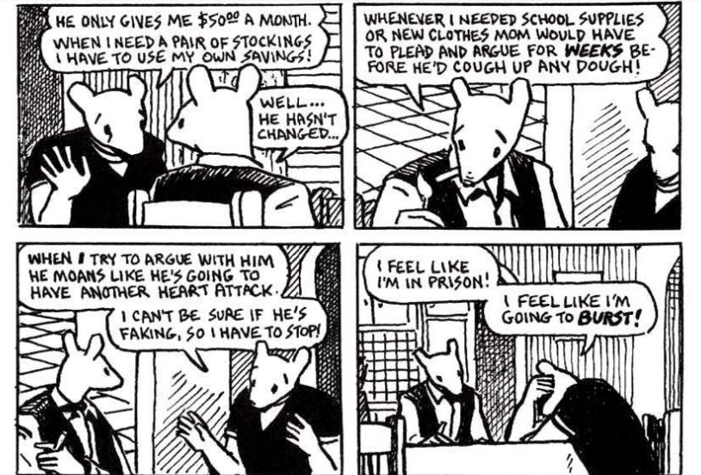Figure 5

